Strategic planning at the University of Montana
  - Progress report, January 2017

The University of Montana's Strategic Plan Coordinating Council (SPCC) invested the last six months of 2016 building the foundation for a new strategic plan by listening to stakeholders on campus, in the Missoula community, across the state of Montana and beyond. The intent of those efforts was twofold: 1) to truly understand the current state of the University, the external environment, and the shared values and collective aspirations of our stakeholders, and 2) to openly and honestly engage people in the process in order to build commitment to the change we must collectively undertake.

Throughout January 2017, the SPCC is analyzing and synthesizing data collected from interactions with nearly 4,000 stakeholders and gleaned from dozens of written documents to create a picture of what we refer to simply as "what is." That will provide common ground for a phase of engagement in which we create and test "what if" scenarios to move the University forward. Our final output, expected by April 1, 2017, will be a high-level strategic plan that articulates mission, vision and values, prioritizes strategic areas of focus, and proposes organizational goals.

We believe campus stakeholders are committed to aligning university processes and decision making with the new strategic plan following its April 1, 2017, release. This alignment will require that leadership dedicate time and resources to ongoing operational planning and assessment and to the difficult work of creating a more adaptive organizational culture.

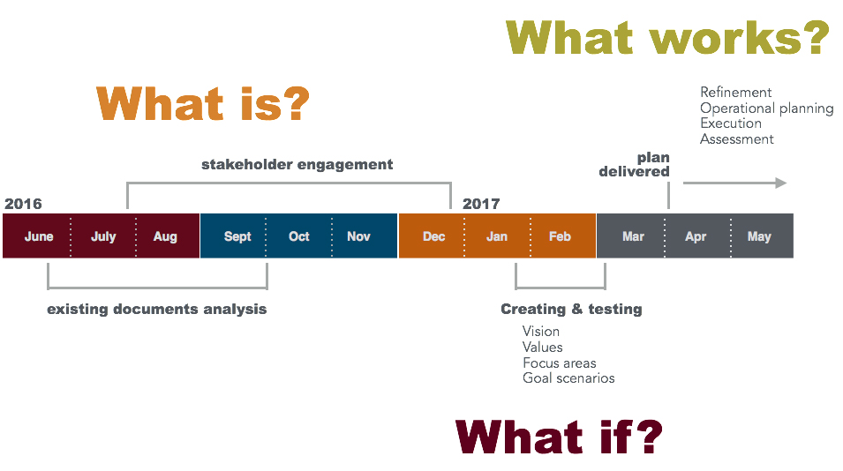

Process and accomplishments to date
Early on, SPCC members committed to a planning process that would be inclusive of many stakeholders, would be open and transparent, and would be informed by data. The group also agreed that it was critical to create a plan that valued experimentation and iteration in order to foster an adaptive culture critical to remaining relevant in the years to come.

From June-December 2016, we pursued two projects to help us fully understand the current state of the University:

- Engagement with a broad swath of stakeholders to gather data about the current state of the University.
- Analysis and synthesis of existing documents that represents recent strategic thinking and direction.

Engagement with stakeholders
We employed multiple strategies to engage nearly 4,000 stakeholders over a six-month period. Those strategies included:

- Interviews with business, government and non-profit leaders in Missoula and across Montana
- Interviews with all members of the Montana University System Board of Regents
- Interviews and focus groups with staff and administrators in the MUS Office of the Commissioner of Higher Education
- Listening sessions with faculty, staff, students, community advisory boards, and other discrete groups
- Participation in public events such as WelcomeFeast (official fall semester kickoff event for UM), Homecoming, Family Weekend, DiverseU, and First Friday (a monthly Missoula event focused on the arts).
- Surveys of faculty, staff, state business leaders, Native American tribal leaders, and rural educators
- Two open-space unconferences
- Online engagement through a digital planning tool called Neighborland

Existing documents review
Early on, UM academic leaders urged the SPCC to incorporate and honor existing strategic thinking and initiatives in our process. Our response was to assess 55 existing documents that included unit strategic plans and reports that addressed issues related to academics, administrative services, enrollment, marketing and communication, technology, diversity, internationalization, and sustainability, to name a few.

We chose to start our process with a blank slate, rather than simply modifying the existing UM 2020 strategic plan. The new plan will include strategic issues organized around themes similar to the UM 2020 plan, but our intent is to describe those themes with greater precision and clarity to generate greater alignment across campus.

We assessed the documents by identifying within them stated strengths and opportunities, weaknesses and threats, strategic directions, alignment with UM 2020, UM's existing strategic plan, and other notable themes and tensions. The exercise allowed us to identify values as well as tensions and gaps between our stated values and our lived campus experience.

SPCC members also regularly cataloged and shared resources focused on national and global trends impacting higher education.

Next steps in the process
During February and March, we will engage in an ideation phase where we develop and tested vision, principles and strategic issues with stakeholders. That will include a week-long exhibition of the core components of the draft plan in a public space on campus with opportunities for feedback. We also visited faculty, staff and student governance groups, administrative leadership teams and departments to share our process and seek feedback.

Our goal is to deliver a draft strategic plan to the University President by April 1, 2017.

